**Software Proposal to Relieve Voltage Spikes**

This section outlines software-based solutions to mitigate voltage spikes. These solutions are intended to be implemented within the DZM ECU. Three methods are considered, including averaging filter, casual median filter and Kalman filter.

1. **Averaging Filter**

The averaging method replaces each current sample with the average of a window of past and current samples. This technique is effective in reducing small-magnitude, high-frequency noise and is commonly used in signal processing for potentiometer-based sensors. In this report, the performance of moving average filters with window sizes of 4, 10, 20, and 50 samples are evaluated. The filtered output is then compared to the raw signal to assess noise reduction effectiveness.

For a window size N, the filtered signal at time i is:

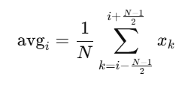

In practice on microcontrollers, we use a **trailing window** (past samples) instead of centered due to real-time constraints.

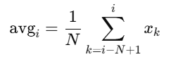

**Figure 9** shows the effect of causal moving average filters (window sizes: 4, 20, 50) on a synthetic potentiometer signal with added noise and spikes. The upper plot compares the full signals, showing that larger windows provide better noise suppression but increase response delay.

A zoomed-in view highlight how:

* A window of **4** slightly smooths the signal while retaining detail.
* **20** reduces high-frequency noise more effectively.
* **50** removes most small noise but introduces noticeable delay.

This illustrates the trade-off between noise reduction and responsiveness, guiding window size selection based on application needs.

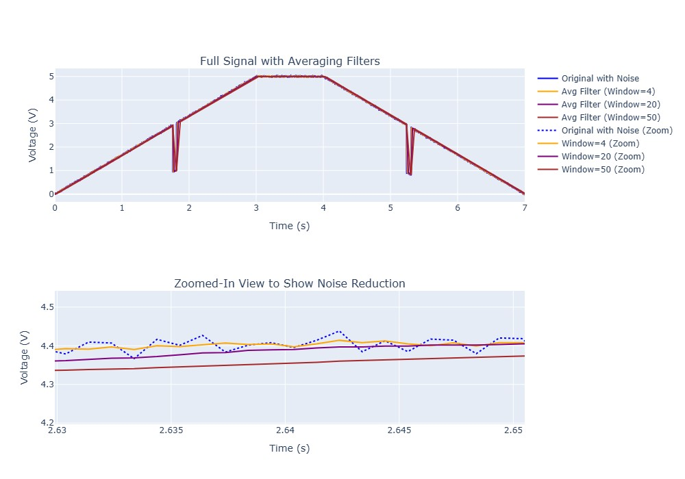

Figure 9: Causal moving average filters (window sizes: 4, 20, 50) smooth noise in a potentiometer signal but introduce delay with larger windows.

**Figure 10** highlights the performance of causal moving average filters in handling a sharp negative spike during the ramp-down phase of the potentiometer signal. The original signal (blue) shows a clear, abrupt voltage drop due to a high-amplitude injected spike.

Importantly, none of the averaging filters fully eliminate the spike. This reveals a key limitation: while averaging filters are effective at reducing small high-frequency noise, they are not well-suited for handling high-magnitude, short-duration spikes. In such cases, alternative filtering techniques, such as median or Kalman filters, may be more appropriate.

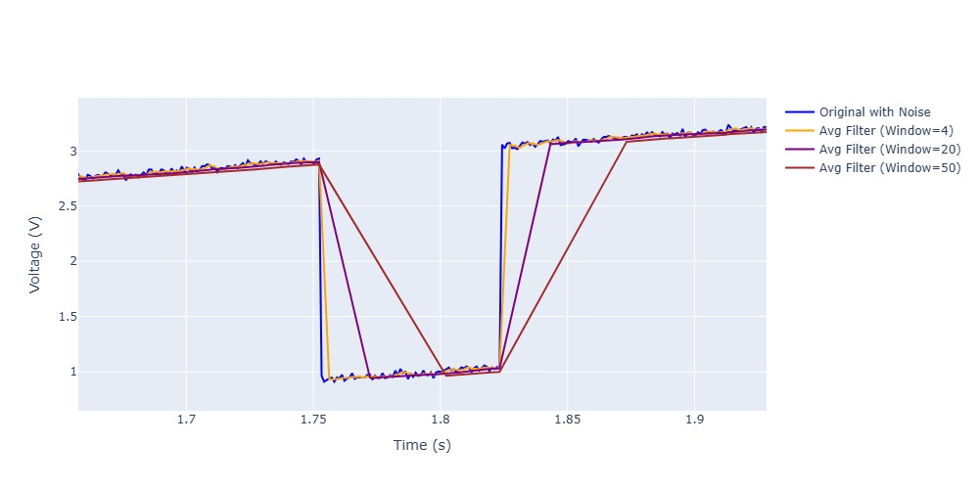

Figure 10. Result of causal moving average filter with different window sizes

The causal median filter is a non-linear filtering method that replaces each sample with the median value from a sliding window of the current and past samples. Unlike the averaging filter, which blends values, the median filter is highly effective at rejecting outliers—making it well-suited for removing high-magnitude voltage spikes from potentiometer signals caused by sensor noise or mechanical disturbances.

In this report, a causal median filter with a window size of 11 samples is used. This size offers a good trade-off between spike suppression and responsiveness. For a window size N (preferably odd to ensure a true median), the output at time index i is the median of the samples xi−N+1​,…,xi​. This causal structure ensures the filter can be implemented in real-time systems, such as microcontrollers.

By selecting the median rather than averaging the values, the filter resists the influence of extreme spikes, making it more effective for transient noise rejection than standard averaging filters.

**Window Size Considerations:**

* **Small (3–5 samples):** Minimal delay, suitable for real-time applications but limited in spike suppression.
* **Medium (7–11 samples):** Balances spike rejection and responsiveness with moderate delay, ideal for most control systems.
* **Large (13–21 samples):** Strong spike suppression but increased delay, potentially unsuitable for fast-changing signals.

The median filter outperforms the averaging filter in scenarios with large outliers, preserving sharp signal transitions while effectively mitigating spikes. However, its non-linear nature may introduce minor artifacts in smooth regions. A window size of 11 samples offers a practical compromise for the door-zone module ECU, ensuring robust spike mitigation with acceptable delay for real-time control.

**Figure 11:** Causal median filter (window size 11) compared to the raw potentiometer signal and an averaging filter (window size 11). The plot demonstrates the median filter's superior spike suppression while maintaining signal integrity, with minimal smoothing of non-spike regions.

**Figure 12:** Zoomed-in view of a sharp negative spike during the ramp-down phase, highlighting the causal median filter's ability to nearly eliminate the spike compared to the averaging filter, which only partially reduces it.

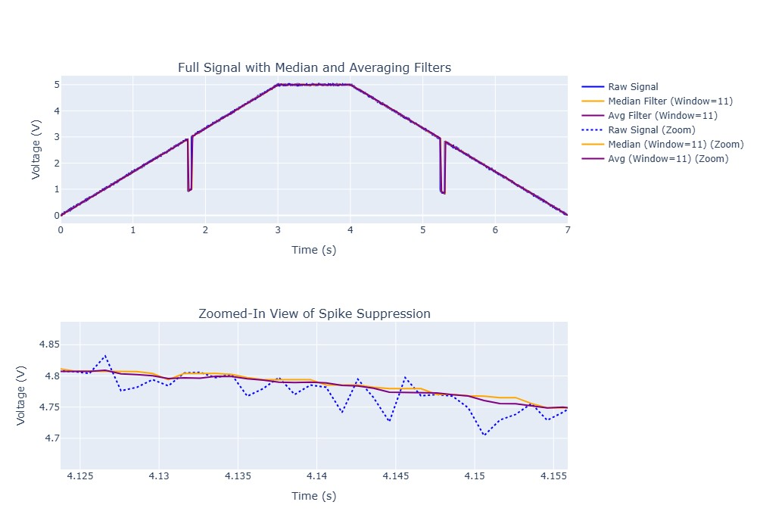

Figure 11. Result of median and average filter implementation on spiky voltage

The zoomed-in view of the signal, spanning approximately 1.6 to 2.0 seconds, highlights a significant limitation of the causal median filter with a window size of 11 samples. In this region, a sharp negative spike (approximately -2 V) is present in the raw signal (blue line), occurring during the ramp-down phase of the potentiometer signal. The median filter (orange line, window size 11) fails to fully suppress this spike. This behavior occurs because the window size (0.011 seconds at a sampling frequency of 1000 Hz) is smaller than twice the spike duration (0.05 to 0.1 seconds). For a median filter to effectively filter out a spike, the window size must encompass at least twice the duration of the spike, allowing the majority of samples within the window to represent the baseline signal rather than the outlier spike. With the current window size, the spike's influence persists, as it occupies a significant portion of the window, preventing the median from shifting adequately toward the surrounding signal values. Increasing the window size to at least 20–25 samples (0.02–0.025 seconds) would likely enable the filter to better mitigate such spikes by diluting the spike's impact with more baseline samples.

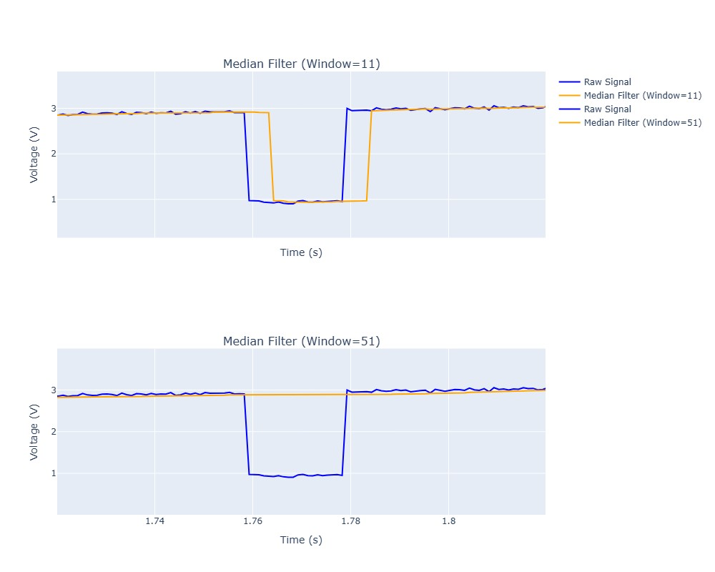

Figure 12. Effect of different window sizes for median filter

Figures 12 illustrates the performance of a causal median filter with different window sizes in suppressing a sharp negative voltage spike in a potentiometer signal. The raw signal (blue) contains a spike of -2 V with a duration of 0.02 seconds, occurring during the ramp-down phase around 1.74 to 1.78 seconds.

**Figure 12 (Median Filter, Window=11):** The median filter with a window size of 11 samples (0.011 seconds at a sampling frequency of 1000 Hz) fails to filter out the spike. Since the window size is less than twice the spike duration (0.04 seconds), the spike influences the majority of samples within the window, preventing the median from effectively isolating the outlier. As a result, the filtered signal (orange) closely follows the raw signal, preserving the spike.

In contrast, the median filter with a window size of 51 samples (0.051 seconds) successfully filters out the spike. This window size exceeds twice the spike duration, allowing the filter to encompass enough baseline samples to outnumber the spike samples. Consequently, the median value shifts toward the surrounding signal, effectively eliminating the spike in the filtered signal (orange), which remains smooth and stable during the spike event.

These figures demonstrate that for a median filter to effectively suppress a spike, the window size must be at least twice the spike duration, ensuring robust outlier rejection while maintaining signal integrity.

**Kalman Filter**

The Kalman filter is an optimal recursive algorithm that estimates the state of a linear dynamic system from noisy measurements, making it well-suited for real-time signal processing in the DZM ECU. In this report, the Kalman filter is applied to the output of a causal median filter (window size 11) to further suppress voltage spikes and smooth the potentiometer signal. The Kalman filter excels in scenarios where the signal dynamics can be modeled, and it can effectively handle both noise and outliers by incorporating a prediction-correction mechanism with spike rejection.

#### State-Space Model

The Kalman filter models the potentiometer signal as a system with two states: voltage xk (the signal value) and velocity dxk/dt (the rate of change of the signal). The state vector at time step k is defined as:

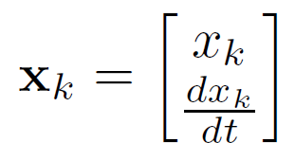

The state transition model assumes a constant velocity, adjusted by the sampling period , where FS = 1000 Hz, so Δt = 0.001 s. The state transition matrix F is:

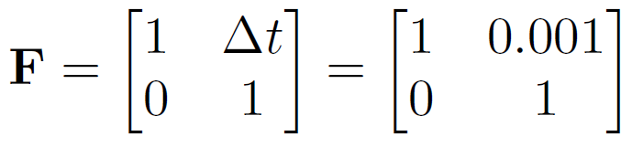

The measurement model relates the state to the observed voltage z_k, which is the output of the median filter. The measurement matrix H extracts only the voltage component:

H = [1, 0]

The process noise covariance matrix Q and measurement noise covariance R are set as:

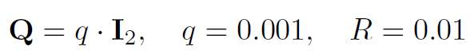

where I2 is the 2×2 identity matrix, q represents the process noise variance, and R represents the measurement noise variance. These values were chosen to balance responsiveness and noise suppression, with R reflecting the expected noise variance after the median filter.

#### Kalman Filter Algorithm with Spike Rejection

The Kalman filter operates in two phases: prediction and update, with an additional spike rejection step to handle high-magnitude outliers. The algorithm is summarized in the following pseudocode:

**Algorithm: Kalman Filter with Spike Rejection**

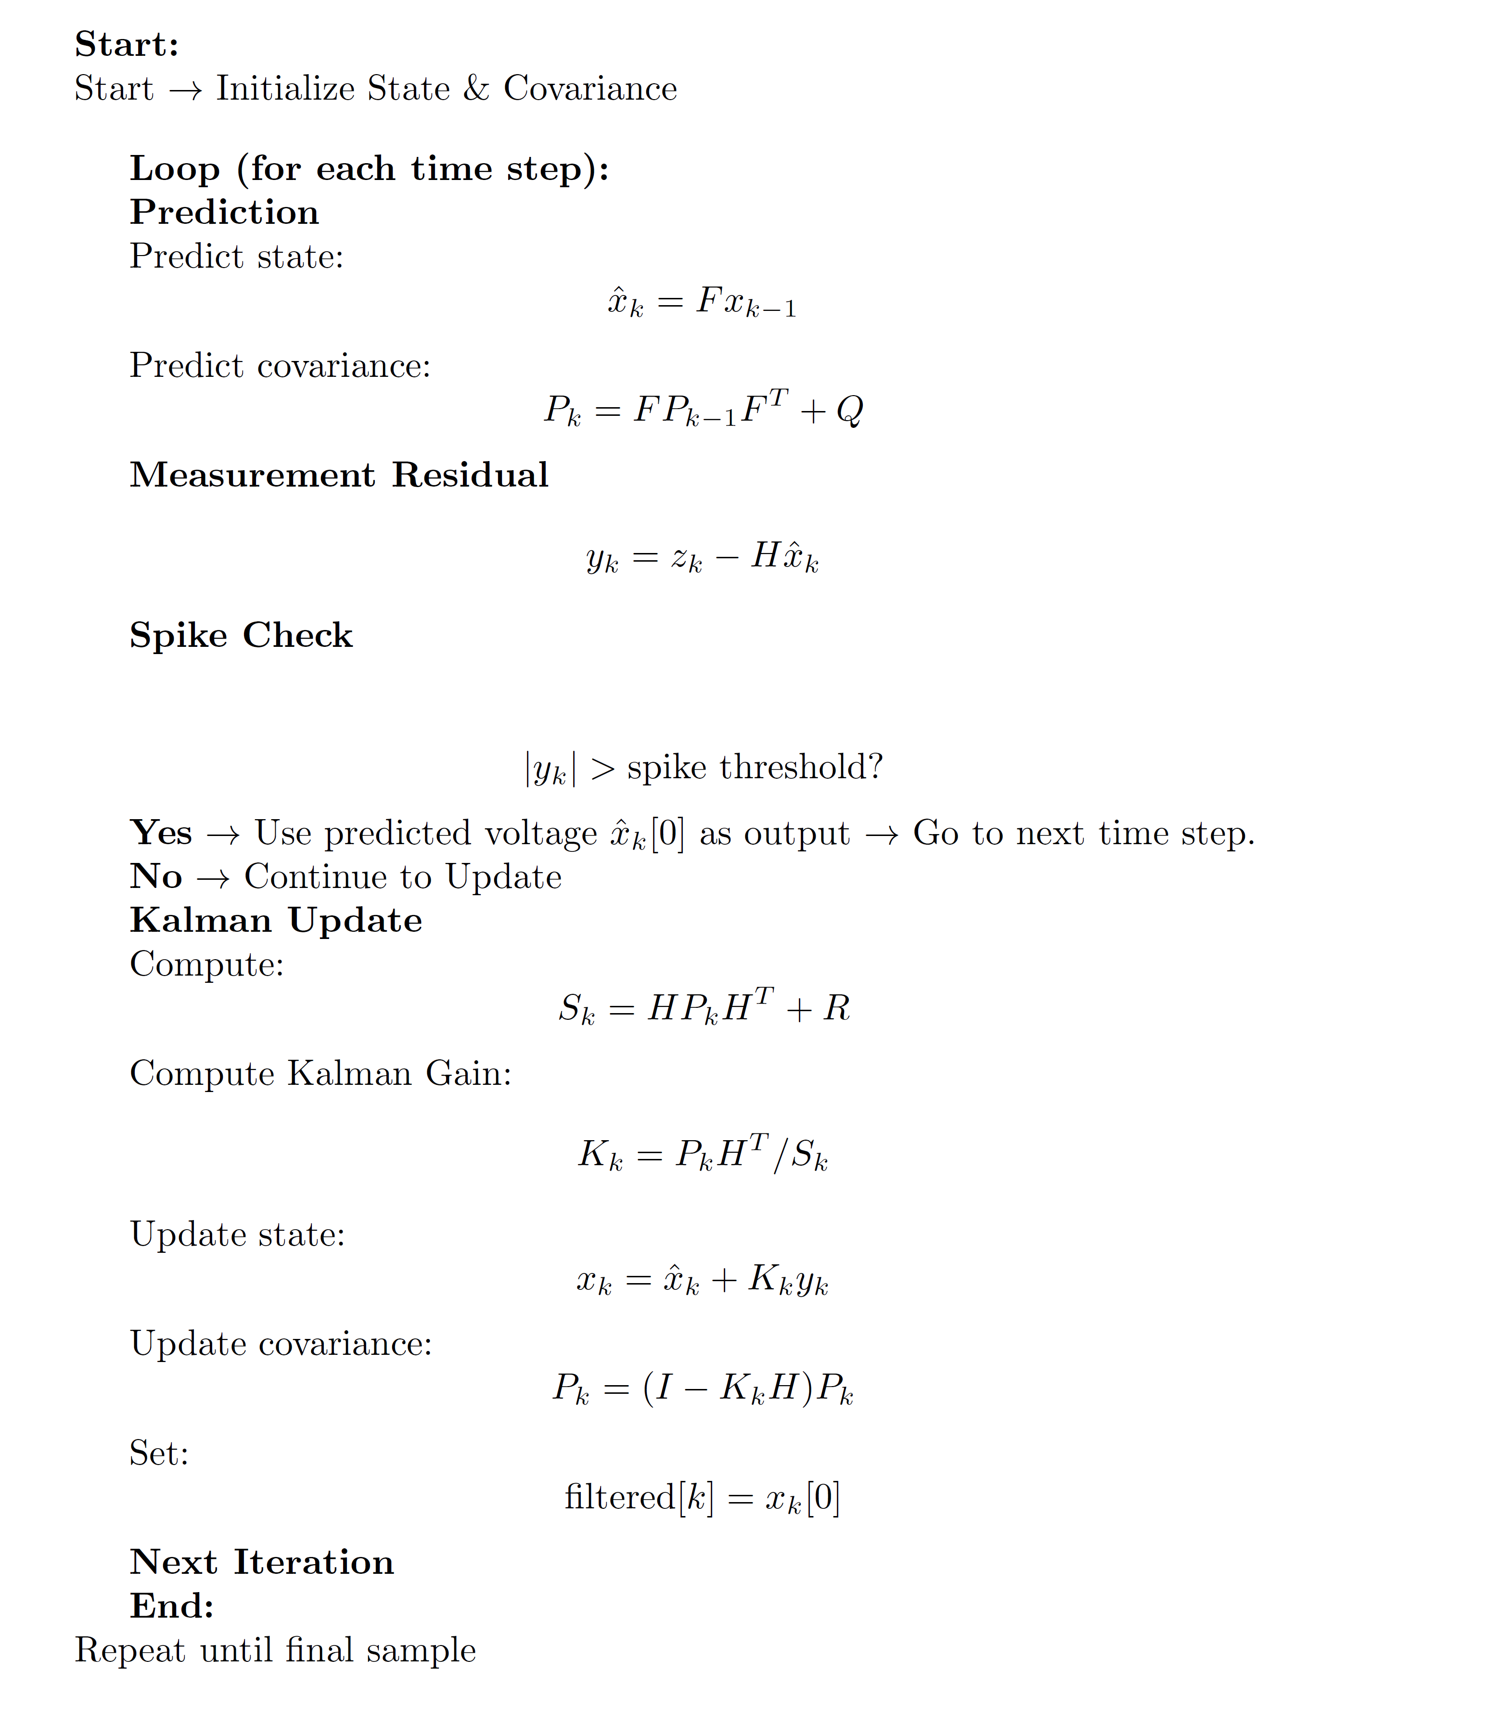

The spike rejection step ensures that measurements deviating significantly from the predicted state are ignored, preventing large spikes from corrupting the filter's estimate. The threshold of 0.1 V was chosen based on the expected signal range and spike magnitude (-2 V), ensuring sensitivity to outliers without rejecting legitimate signal changes.

#### Performance Analysis

The Kalman filter, applied after a median filter (window size 11), leverages the median filter's initial noise reduction to improve its state estimation. The median filter reduces small-magnitude noise but fails to suppress spikes (as seen in earlier sections), while the Kalman filter uses its predictive model and spike rejection to further smooth the signal and eliminate outliers.

**Figure 13:** Comparison of the raw potentiometer signal, the median-filtered signal (window size 11), and the Kalman-filtered signal (applied after the median filter). The raw signal (blue) contains a -2 V spike of 0.02 seconds duration. The median filter (orange) reduces noise but fails to remove the spike due to its small window size. The Kalman filter (red) effectively suppresses the spike by rejecting measurements exceeding the 0.1 V threshold and provides a smoother signal, demonstrating its ability to combine predictive modeling with outlier rejection for improved signal quality.

In conclusion, the Kalman filter offers superior performance over the standalone median filter in handling high-magnitude spikes, making it a strong candidate for the DZM ECU. However, its computational complexity is higher due to matrix operations, which must be considered for real-time implementation on microcontrollers. Tuning parameters like q, R, and the spike threshold can further optimize its performance for specific application needs.

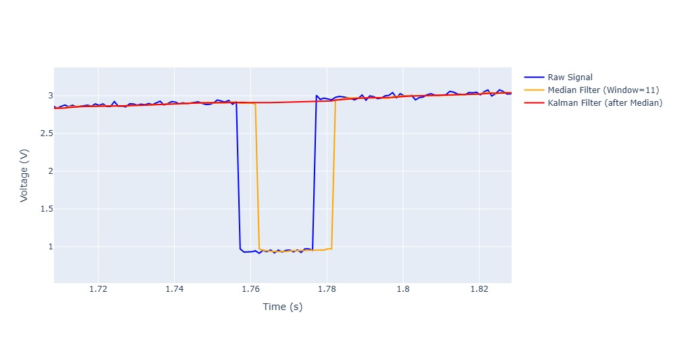

Figure 13. Result of implementing Kalman filter on spiky voltage